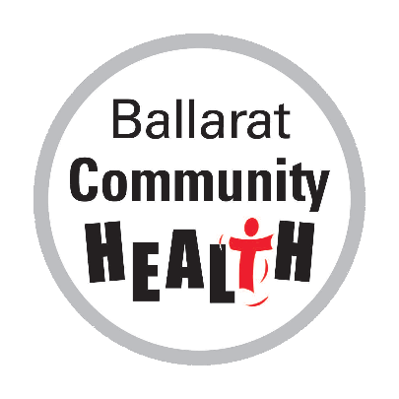
2020 IT STARTS WITH YOU

Postcard Art & Writing Competition and Exhibition

Entry Form
Terms and conditions
Artwork/Writing must be original artwork/writing of the artist/writer. All entries must be received by the competition closing date 27th July 2020. The Winners will be announced on the week of 31st August 2020. Details of exhibition opening will be provided to applicants via an official invite.
Competition and exhibition is open to the following 12-25 year olds
- Artist’s/writer’s with a lived experience of family violence
- If you know someone with a lived experience of family violence
- An artist/writer making work promoting awareness about Family violence
Entrants can submit art or writing to all three taglines or just one
- Break the Silence
- The Power of words
- Let me Love you, Not Fear you
All artwork is to be submitted digitally via WeTransfer and will be sized at A4, Resolution 1200 DPI Go to https://wetransfer.com/ add your files and put tashkahl@bchc.org.au in the email to box
Artwork/writing will be exhibited later in the year when COVID-19 restrictions have been eased Multi-media exposure will be used during the exhibition.
Please note:
- Art Works can be in any medium but will need to be submitted digitally in the above format
- Applications are accepted at the discretion of the BCH judging panel, not all works are guaranteed to be accepted
- Artistic or literary material created for the Postcard Competition shall remain the property of the creator/entrant, but Ballarat Community Health shall be permitted to use or modify such material for any future instructional, educational, or campaign purposes in perpetuity, while always acknowledging the original source.
- Self-care guidelines
We acknowledge that the topic of family violence is a challenging one, and that the process of writing or making art about this topic may stir up some bad feelings for you. We encourage you to care for your wellbeing during this process – stop and do something you love, talk to a friend or reach out to services for more support or guidance.
You can seek help or advice from 1800RESPECT 1800 737 732 (24 hrs) or Kids Helpline 1800 55 1800 (24 hrs) inquiries please contact: Tashkah at Ballarat Community Health e: tashkahl@bchc.org.au

2020 IT STARTS WITH YOU

Postcard Art & Writing Competition and Exhibition

Entry Form
Name of Artist/Writer ___________________________________________________________
Artist/Writer Contact Number: ___________________________________________________________
Artist/Writer Address: ___________________________________________________________________
Artist/Writer email: _____________________________________________________________________

Title of Artwork/Writing
Medium Used:__________________________________________________________________________________
Artist/Writer Signature to acknowledge that they have read the Terms and Conditions
I (name) ______________________ have read and agree to the terms and conditions.
Signed ________________________ Date _________________________________

